Registration form
Advanced Component Theory
Deadline for registration: 3 weeks before the first training day
Location:  Distance Learning – see separate description.  Monday – Friday  08.00 – 16.00 CET (Europe) | Date:  Week 47: November 16th + 20th, 2026
Seat price (ex. VAT): | Included in price:  Training, materials, and certification are included in the price. The invoice will be sent to you after we have received your registration. Please note that the invoice is due before the training begins.
  1 seat | EUR 3,995
  2 seats | EUR 7,490
  3 seats | EUR 10,985
  4 seats | EUR 14,480
  5 seats | EUR 17,975
Course Invitation | Further information regarding location and preparation, etc. will be sent to you after we have received the completed registration form.
Information for the invoice:
Company name and address:
Invoice address:

VAT number:
P.O. number:
Responsible contact person full name, email & phone no.:
Accounts Payable full name, email & phone no.:
Email address for invoices:
Responsible contact person related to Withholding Tax full name, email & phone no.:
Delivery address for the course material.

(must be a company adress)

Please fill in PARTICIPANT INFO on next page
Thank you for the registration!
Please fill out below Registration Form and send the filled-out Registration Form to nhe@danishwpa.com.

PARTICIPANT INFO (Used for Trainers preparation) |  |  |  |  |  |  |  |  | PRE COURSE KNOWLEDGE INFO BY PARTICIPANT
No | Name |  | Site/  Windfarm | Job title | Email | Cell phone | Nationality | Age | English | IT skills | Education | Expirence in wind/years | Mechanical | Hydraulics | Electrics | Controls | Working on which WTG Type | Experience in other turbine types? (Write which ones)
ex. | Jack sparrow |  | Black Pearl WF | Tech 1 | JS@danishxxx | +1 234566789 | US | 30 | 100% | 75% | Electrician | 5 | 75% | 50% | 50% | 75% | SWT 2.3vs | GE/Vestas
1
2
3
4
LEGEND
English Technical Language  Type in the number which match the participant's skills:  0% = Can NOTHING  25% = Able to READ  50% = Also able to UNDERSTAND  75% = Also able to TALK  100% = Also able to WRITE |  |  |  |  |  |  |  |  | IT- Skills of Microsoft office products  0% Can not start a PC or laptop  25% = Need supervision all the time  50% = Need some assistence  75% = User level  100% = Expert level |  |  |  | Skill Levels  0% = No Knowledge  25% = Very limited skills  50% = Basic skills level  75% = High skills level  100% = Expert level

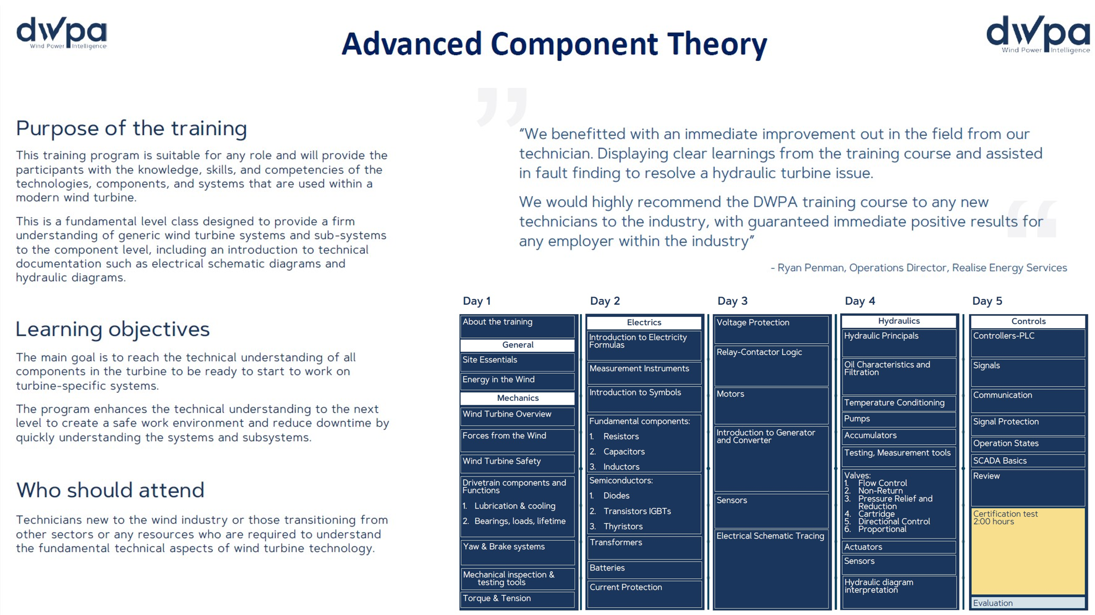

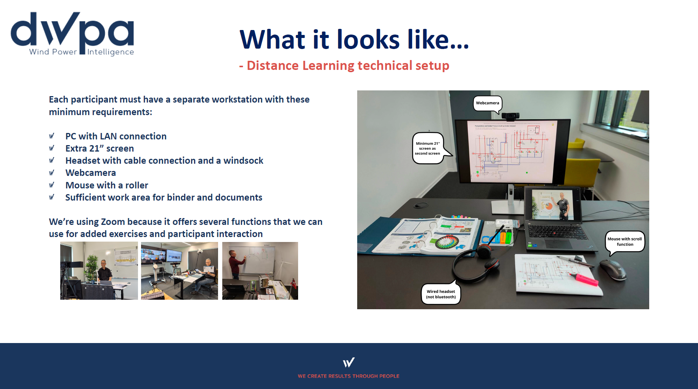

terms & conditions
