Registration form
Siemens SWT 3.6MW
Advanced Platform Theory
Deadline for registration: 4 weeks prior to the first training day
Location:  UK (Manchester area)  Monday – Friday  08.00 – 16.00 CET (Europe) | Date:  Week 49: November 30th-December 4th, 2026
Price per participant: | Included in price:  Training, materials, and certification are included in the price. Lunch and refreshments will be included during the training. The invoice will be sent to you after we have received your registration. Please note that the invoice is due before the training begins.
  1 seat | €6,900
  2 seats | €13,300
  3 seats | €19,700
  4 seats | €26,100
  5 seats | €32,500
Course Invitation | Further information regarding location and preparation will be sent to you when we receive the completed registration form.
Information for the invoice:
Company name and address:
Invoice address:

VAT number:
P.O. number:
Responsible contact person's full name, email & phone no.:
Accounts Payable full name, email & phone no.:
Email address for invoices:
Responsible contact person related to Withholding Tax full name, email & phone no.:
Delivery address for the course material.

(must be a company address)

Please fill in PARTICIPANT INFO on next page
Thank you for the registration!

PARTICIPANT INFO (Used for Trainers preparation) |  |  |  |  |  |  |  |  | PRE COURSE KNOWLEDGE INFO BY PARTICIPANT
No | Name |  | Site/  Windfarm | Job title | Email | Cell phone | Nationality | Age | English | IT skills | Education | Expirence in wind/years | Mechanical | Hydraulics | Electrics | Controls | Working on which WTG Type | Experience in other turbine types? (Write which ones)
ex. | Jack sparrow |  | Black Pearl WF | Tech 1 | JS@danishxxx | +1 234566789 | US | 30 | 100% | 75% | Electrician | 5 | 75% | 50% | 50% | 75% | SWT 2.3vs | GE/Vestas
1
2
3
4
LEGEND
English Technical Language  Type in the number which match the participant's skills:  0% = Can NOTHING  25% = Able to READ  50% = Also able to UNDERSTAND  75% = Also able to TALK  100% = Also able to WRITE |  |  |  |  |  |  |  |  | IT- Skills of Microsoft office products  0% Can not start a PC or laptop  25% = Need supervision all the time  50% = Need some assistence  75% = User level  100% = Expert level |  |  |  | Skill Levels  0% = No Knowledge  25% = Very limited skills  50% = Basic skills level  75% = High skills level  100% = Expert level

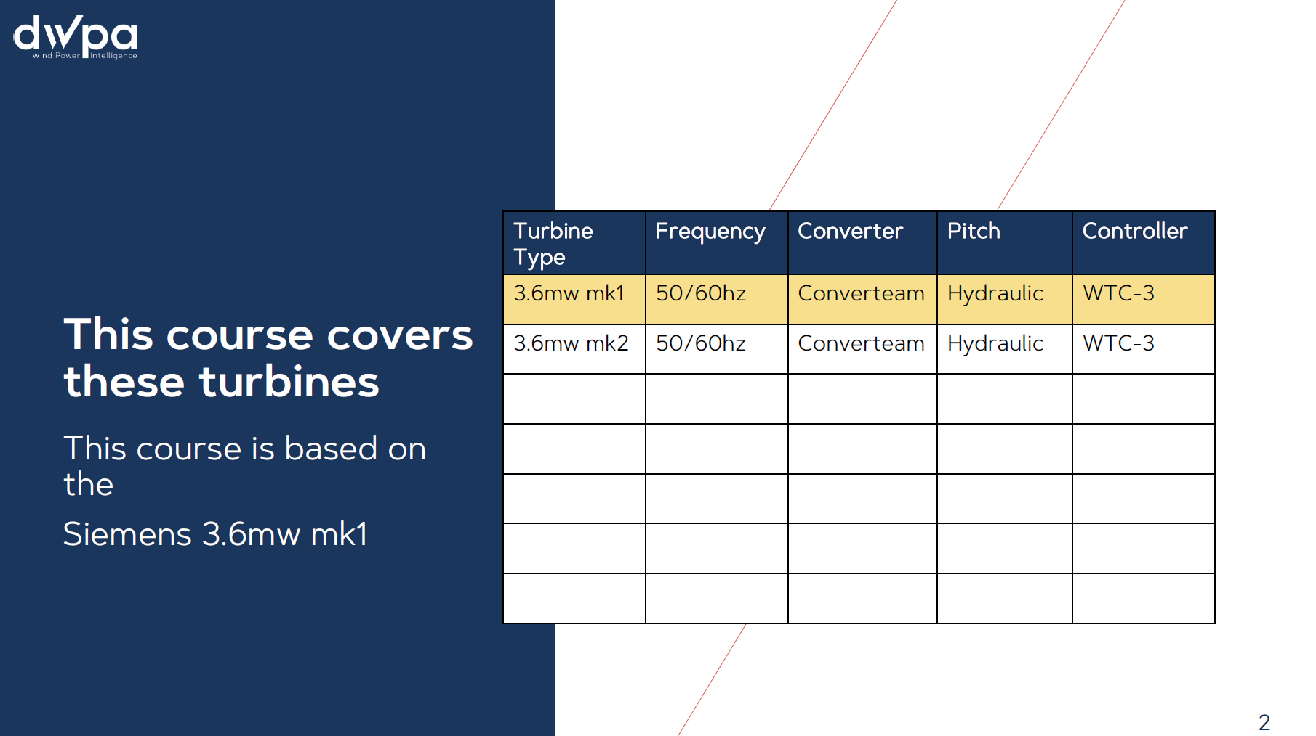

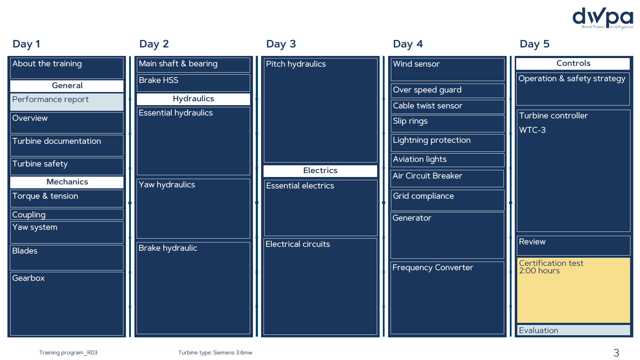

terms & conditions
